Приложение
Раздаточный материал для учащихся
№1.

Read the words to yourselves and put them to the categories according to the word stress: Approve, rely, argument, common, relationship, establish, relate, sibling, accommodate, adolescence, interaction, connection.

The 1-st syllabus

The 2-nd syllabus

The 3-rd syllabus

The 4-th syllabus
№ 2.
Word list
control
obey
support
care for
comply with
get on with
under one roof
have a lot of argument with
interfere
approve of
rely on
be close to
get on like a house on fire
get on one’s nerves
have smth in common
see eye to eye
establish a connection with
break down a relationship
see smth in smb

Expressing opinions:
In my opinion, ...
In my eyes, ...
To my mind, ...
As far as I am concerned, ...
Speaking personally, ...
From my point of view, ...
As for me / As to me, ...
My view / opinion / belief / impression / conviction is that ...
I hold the view that ...
I would say that ...
It seems to me that ...
I am of the opinion that ...
My impression is that ...
I am under the impression that ...
It is my impression that ...
I have the feeling that ...
My own feeling on the subject is that ...
I have no doubt that ...
I am sure / I am certain that ...
I think / consider / find / feel / believe / suppose / presume / assume that ...
I hold the opinion that ...
I dare say that ...
I guess that ...
I bet that ....
I gather that ...
It goes without saying that ...
To be honest …
The impression I get is that…

Describing similarities and differences:
Compared to…
In contrast to…
Similar/almost identical to…
Slightly/completely different from
…(not) as … as
…less …. than
Compared with….
….is much more ….than….
№ 3.
What is the main idea of these quotes?
- The best of times are always found when friends and family gather round.
- Friends are the family we choose for ourselves.
- I've learned that family and friends are what make us who we are today and without them we would never be complete.

You don't need money to lead a rich life. Good friends and a loving family are worth their weight in gold.
- It does’t n matter where in the world you live, as long as you are surrounded by family and friends you love and are loved by, then you’re at home.

№4.
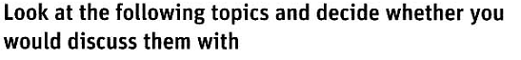
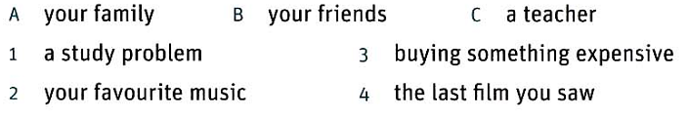
№5.
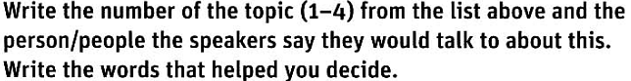
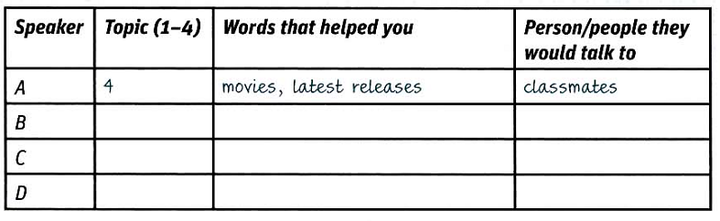
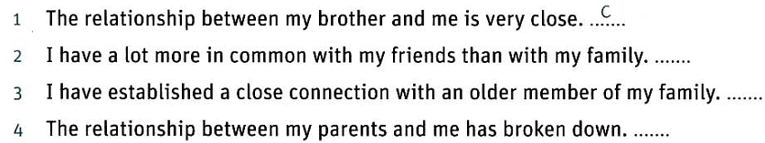
№ 6. Use words and phrases from the recording to complete the sentences.
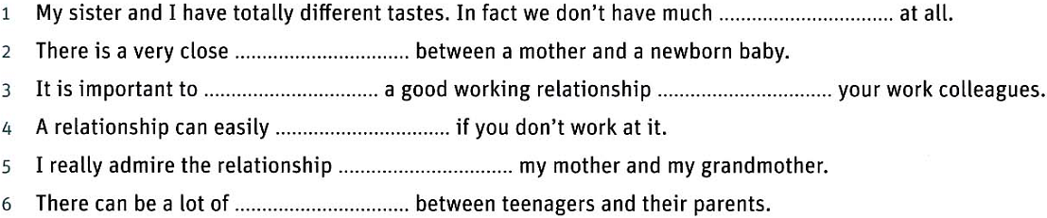
№ 7. Prepare a talk on family and friends. Use the questions as a plan.

Which of the quotes about family and friends is closer to you?

Do family and friends play an important role in your life? Why?

Is it easy to have a good relationship with your family? Friends?

What makes friends different from family?

What do they have in common?

What is more important for you: having a good relationship with your family or with friends? Give reasons.

